Section B - Biology of an Olive Tree

Phenology By Sandy Lang

To understand how our management practices might impact on fruiting and yield, one must first have some understanding of the various processes involved in fruiting and their timings. Phenology is the term given to the study of how a plant’s annual growth cycle (especially of reproductive growth) responds to changes in the environment. Primarily these growth responses are to the weather (seasonal changes in light and temperature etc) but most of our management practices also have their influences on the fruiting process.

In olives, the seasonal ‘wheel’ of growth is driven mostly by temperature. Day length is not as much involved as it is with many more ‘temperate’ plants.

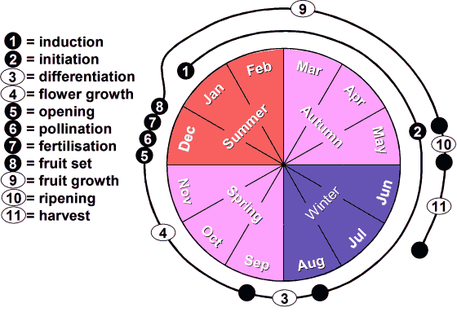Figure 1. The phenology of flowering in olives. Months, refer to a S-Hemisphere climate. Timings are approximate and will differ by a few weeks from one cultivar to another and from one part of New Zealand to another.

Floral induction (1)*: Before you can have fruit, you must first have flowers and the flowering process actually starts almost a full 12-months before bloom - around January in the previous year. It is at this time that the dormant buds on ‘this’ year’s wood make the ‘decision’ as to whether they will develop into floral structures (inflorescences) or vegetative ones (leafy shoots). The bud’s decision to become floral is termed ‘induction’. *The bracketed numbers refer to the sequential stages in Fig. 1.

Floral initiation (2), differentiation (3) and growth (4): The decision to become floral is not actioned for another four months till late autumn. About May, the dormant bud ‘initiates’ the growth processes that will turn it into an inflorescence. During the following cold, winter months development is correspondingly slow, so it is not until August that microscopic inspection of the bud can distinguish the beginnings of an inflorescence. It takes another month, until September, before the tiny floral structures are all in place – still very small and tightly pressed together in the bud. After this, the flowers must grow and expand for a further two or three months (bud break) until they are ready to open in December (Fig. 2).

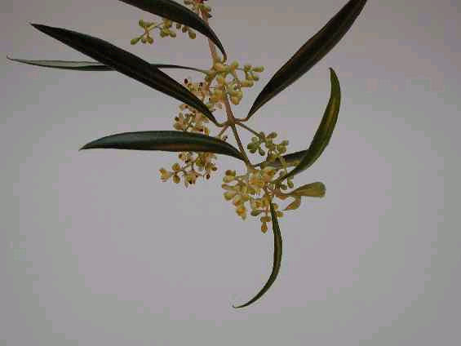

Figure 2. Several inflorescences on an olive shoot (one inflorescence per leaf axil, several flowers per inflorescence).

Bloom – opening (5), pollination (6), fertilisation (7) and fruitset (8): In the warm weather of late spring and early summer, a great deal now happens over a comparatively short period. The flowers open (Fig. 3) and the anthers liberate their pollen (Fig. 4) which is dispersed in the wind (Fig. 5) a tiny proportion of it eventually finding its way on to the stigma of a healthy flower where the grain germinates (Fig. 6) and its pollen tube grows to meet up with the waiting ovule in the base of the flower so allowing fertilisation to take place. Most flowers (c. 98%) fall off about now with just a very few (c. 1-2%) remaining on the tree. Over the next few days, not much happens that is visible to the naked eye but the developing embryo soon stimulates (hormones) the ‘lucky’ flower bases to start the process (fruitset) of developing into tiny fruitlets (Fig. 7).

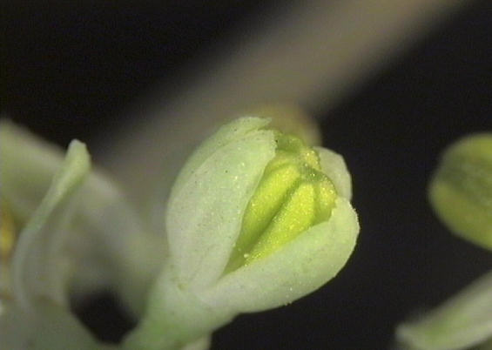

Figure 3. Flowers open to expose yellow anthers.

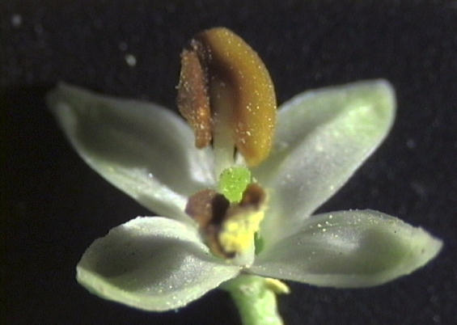

Figure 4. Anthers dry (brown) and dehisce liberating their pollen.

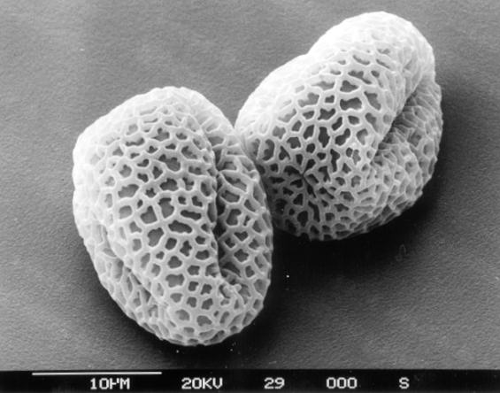

Figure 5. Two pollen grains awaiting wind dispersal (scanning electron microscope image - courtesy Doug Hopcroft, HortResearch).

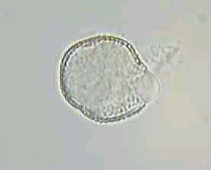

Figure 6. A germinating pollen grain soon to fertilise an ovule. The emerging pollen tube (right side) must grow to a length of about 200-times the diameter of the pollen grain before it reaches the ovule and fertilisation can occur (light microscope image - Sandy Lang).

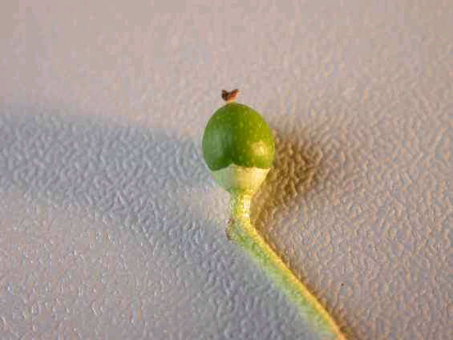

Figure 7. A young olive fruitlet 17 days after bloom.

Fruit development: After a slowish start, the rate of fruit growth accelerates and progresses through to maturity some 5-6 months later (Fig. 8).

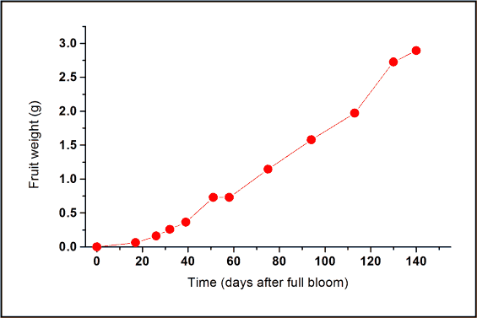

Figure 8. Fruit weight increases steadily over 5-6 months.

Ripening: Lastly, when growth has slowed somewhat towards the end of May, ripening occurs. This takes place over about 2 weeks (Fig. 9).

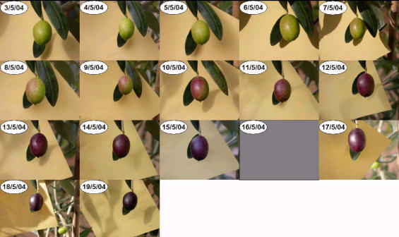

Figure 9. A sequence of 17 daily photographs (1 missing) of a particularManzanillo fruit as it advances towards maturity. A blackbird took the fruit on 20/5/04.

Maturity spread: The spread of maturities in the population of fruit on a particular tree at the time of harvest usually spans about two weeks. The spread of maturities over several trees (some inevitably a bit more advanced than others) is usually a little wider – perhaps three weeks. It is not practicable with olive to carry out sequential picks so as to harvest fruit on each occasion only of a certain maturity (as one does for example with cherry). Instead a ‘strip-pick’ is carried out of all trees of a particular cultivar at substantially the same time.

The consequence is that bins of fruit awaiting pressing, inevitably contain individuals of a wide range of maturities with some only just starting to mature (late ripening – fully green fruit) and others fully, or even somewhat over, mature (early ripening – fully black fruit). A degree of judgement is required so as to strike the right moment at which to harvest. Any timing is a compromise of course, that avoids having too many of the population of fruit going to press being rather under-ripe (on the one hand) or too many of them being rather over-ripe (on the other) - Fig. 10a, b.

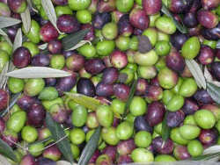 (b) 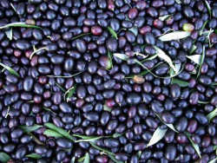

Figure 10. Olives awaiting pressing. The maturity spread is 2-3 weeks. The fruit in (a) are perhaps a bit under-ripe and in (b) perhaps a bit over-ripe.

